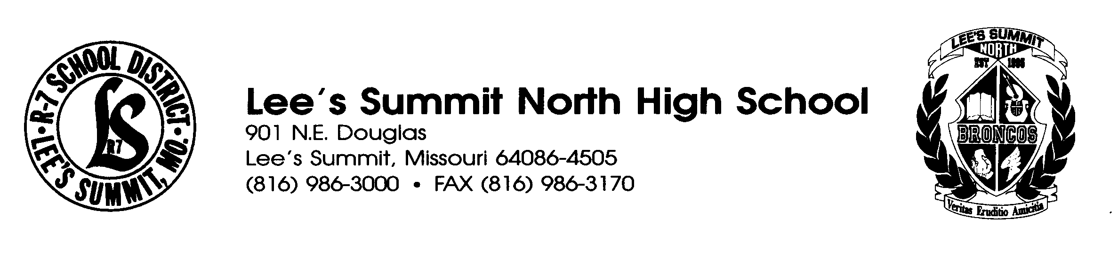
18th Annual Lee's Summit North
Bronco Classic Scholar Tournament
Saturday, December 1st, 2012

August 23, 2012

Dear Coaches,

Lee's Summit North High School will be once again be hosting the 18th Annual Bronco Classic Scholar Team Tournament on Saturday, December 1, 2012. This year, the tournament will host up to 20 Varsity and 20 Junior Varsity Teams. If the entry level exceeds 16 teams in competition either level, the tournament will further break down into a “Large School” (Crimson) and “Small School” (Silver) division, based on MSHSAA enrollment. Every team is guaranteed three games in the morning, with the top eight teams of each division advancing to the afternoon rounds.
Registration for the tournament and drawings for Swiss pairings will begin at 8:00 at the west entryway, followed by a coaches' meeting at 8:30 in the Lecture Hall. The first round will begin at 9:00. A Hospitality Room will be set up in the Faculty Lounge for coaches and bus drivers.
The entry fee for the tournament is $60 per team, with a $10 Buzzer deduction for each working buzzer set you bring. Trophies will be awarded to the top four teams, with gold and silver individual medals awarded to the members of the top two varsity teams. The deadline for registration is November 20, 2012 to allow for ordering trophies and medals. For your planning (buses, permission slips, etc.) confirmations will be e-mailed as entries are received. A periodic group listing will also be sent out so each coach can determine which teams they will have the pleasure of competing against. Each coach will also receive an information packet at check-in.
Chuck Stephenson will be running the tournament for us this year, so please forward all entries and inquiries to him. If you have any questions, please contact Chuck Stephenson at the address and phone numbers below. Contact information for all of our leaders is below.

Sincerely,

Deborah Parker, Varsity Coach Bill Hume 986-1499 ext. 8946 LSN Phone – (816) 986-3027
LSN e-mail – deborah.parker@lessummit.k12.mo.us LSN e-mail –bill.hume@leesummit.k12.mo.us

Chuck Stephenson
LSN Phone - (816) 986-1499 ext 8263
LSN Fax - (816) 986-3170
Home Phone - (816) 478-6499
Cell Phone – (816) 799-8547
LSN e-mail - chuck.stephenson@leesummit.k12.mo.us
18th Annual Bronco Classic
Scholar Team Tournament
December 1, 2012

Name of School ____________________________________________

Name of School District ______________________________________

School Address ____________________________________________

________________________________________________

School Phone ______________________________________________

School Fax # _______________________________________________

Coach's Name (s) __________________________________________

Coach's Home/Cell Phone (optional, but important if there is bad weather) ___________________________ ____________________________

Coach's e-mail _____________________________________________

I am bringing a _____ Varsity Team _____ Junior Varsity Team

(a second team in each division will be allowed only if space allows after each school has been allowed 1 team each)

______ Payment enclosed for $60 per team - $10 Buzzer

______ Purchase order issued

______ I need an invoice from Lee’s Summit North H.S.
*** Please make checks and purchase orders payable to "LSN Scholar Team"

(information below for LSN use)
Date Application Received _____________________________

Payment Received Yes__________ No___________

